**ALTUI / Thingspeak integration**

This integration enables to trace variable values without having to have a local database or repository. It is based on the thingspeak cloud free service and wil keep your data for a long time as well as enable some complex graphic or analysis if you want

To enable this , you will have to follow this 2 Steps process

1. Preparing a channel in Thingspeak
2. Configuring ALTUI

**Step 1 : Preparing a channel in Thingspeak**

1. Create your account on Thingspeak

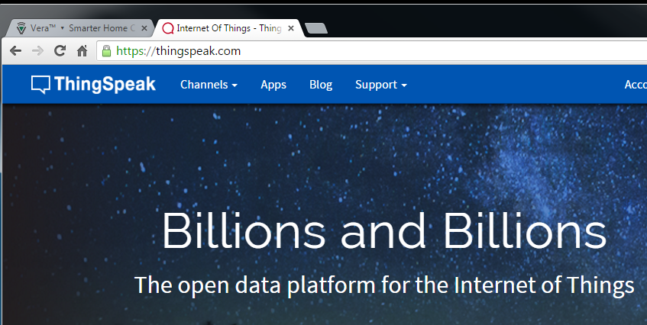

1. Create a Channel and select up to 8 fields to report on 8 metrics
   1. Remember which metrics goes to which field number ( 1 to 8 ) that will be needed later

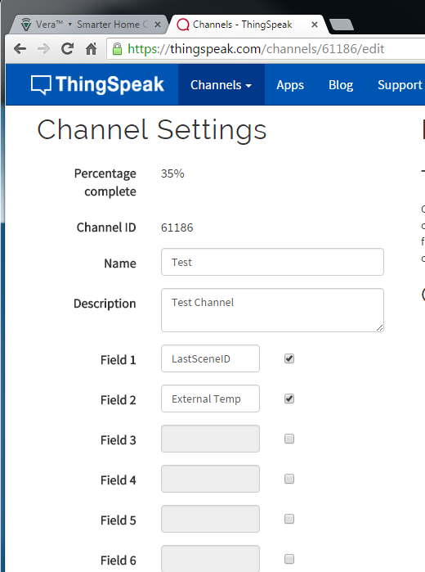

1. Once done go to My Channels : Channel Settings and note down the Channel ID

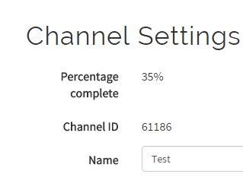

1. Still in My Channels goto API Keys and note down
   1. The Write API key
   2. The Read API key : this on is only needed if your channel is not public ( private )

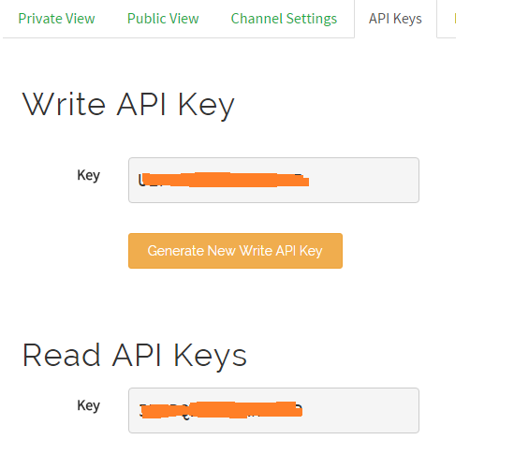

1. Later on , once you are happy and get plenty of data, you can use MathLAB analysis or MathLAb Vizualisation to create many smart graphics with your data, or “Internet of Things” scripts to trigger actions based on your data ( tweeter etc … )

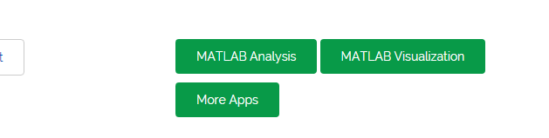

**Step 2 : Configuration ALTUI**

This should be simple. ALTUI device has a new variable **VariableToSend** but you do not really have to use it directly

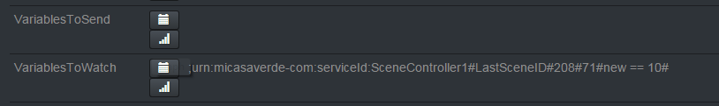

1. Go to your device for which you want to capture data and open Variage

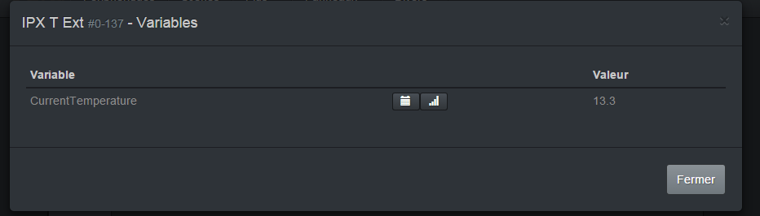

1. Choose your variable and click the barChat icon button and clikc the Enable Push to THingspeak checkbox and fll in the information for the write & read channel key, the channel ID and the field number for that variable ( from 1 to 8 remember )

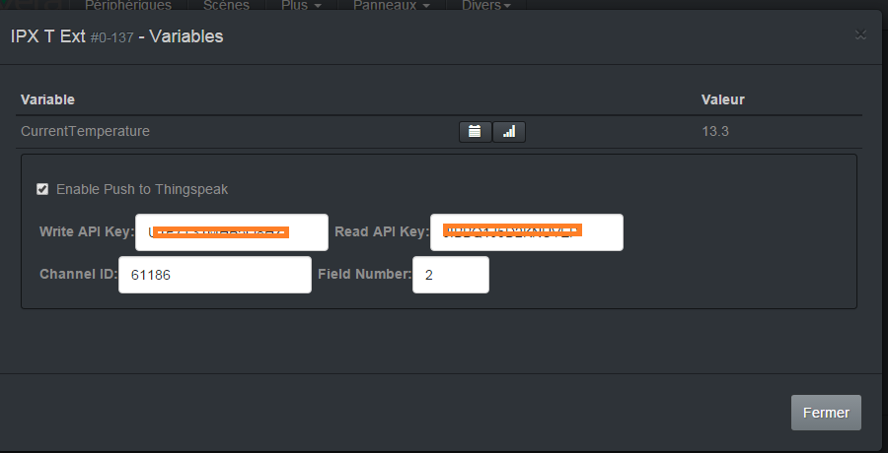

1. In order **to save, click again the BarGraph Icon button** to close that thingspeak parameter editor lines.

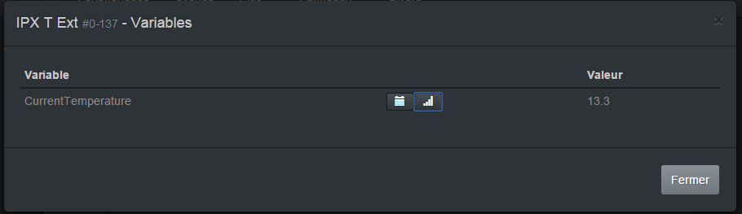

1. Then Close the dialog
2. Do the same from step 1) for other variables you want
3. If you are curious you can see the changes in the ALTUI variable 
4. Do a Luup restart => MANDATORY to take changes into account
5. Once variable start to send data to Thingspeak ( at each change ) , you can go back to the Device Variable and open the barGraph icon again. It will show the graph

